International Conference on Philanthropy Research
22 and 23 September 2022
Collegio Carlo Alberto
Turin

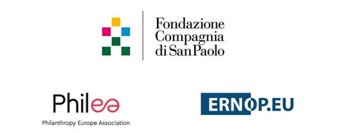

Contents

Introduction 3

Agenda 5

Let’s dance Experiences and next moves from the International

Philanthropy Research Conference 7
Waiting for the music to start: Philanthropy and philanthropy researchers 7
Dancing in the dark: Barriers to collaboration 8
Finding our rhythm as partners 9
In sync: The ERNOP-Philea Partnership 10
Next steps 12
Contact 12
ANNEX: Conference programme 13
Organisers 13
Speakers 15
Venues 23

Reflections on the International Philanthropy Research Conference

Introduction

“I am convinced that research and philanthropy make perfect partners. The history of modern philanthropy shows it.” With these words, Francesco Profumo, Chair of Compagnia di San Paolo Foundation, opened the recent International Conference on Philanthropy Research, organised in close cooperation with ERNOP and Philea. The three organisations believe in the importance of philanthropy research and tighter cooperation between researchers and professionals; and in the creation of a modern and sustainable model of philanthropy.

The first day was dedicated to ERNOP’s annual meeting, where, in four workshops, crucial topics on the current situation of philanthropic research, as well as its future direction, were discussed in the context of a joint research project on philanthropy across Europe. On the following day, practitioners and academics had the chance to engage in a debate dedicated to key aspects of scientific research on philanthropy, such as data availability and specific investigation methodology. The outcome of both days will merge into a COST action that ERNOP will submit to the European Commission.

Foundations and academia are, by nature, ever-reforming and ever-evolving institutions. They are required to keep up with major societal changes to remain useful or avoid becoming obsolete. In a data-driven society like the European one – and even more now considering the pandemic and war on the continent – philanthropy can benefit greatly from research regarding its missions, its modus operandi, and its allocation choices. Additionally, research can help maximise impact and support growth, transparency, and accountability.

The five papers that were presented in the main panel ranged from the promotion of philanthropic networks to fostering interdisciplinary research and the enhancement of impact evaluation, also taking into account the increasing need ‒ but also the legitimacy ‒ at the very heart of philanthropic actions.

Starting from the framing paper by Rien Van Gendt, advisor on the project to Fondazione Compagnia di San Palolo (CPS), the session focused on the state of philanthropic research in the last decade and a half, presented by René Bekkers, Professor of Philanthropy, VU Amsterdam. Liz McKeon addressed topics around legitimacy and the relationship between philanthropy and democracy, at a time when we are facing diminishing democratic values across various countries. Gianpaolo Barbetta, of Università Cattolica del Sacro Cuore of Milan and Director of Evalab Fondazione Giordano Dell’Amore, delivered a presentation on the methodological aspects of the very nature of impact and its evaluation. The papers' presentation was closed by Volker Then, Chief Executive Officer and Member of the Executive Board of Fondazione AIS – Advancing Impact and Sustainability, who spoke about the importance of listening to grantees and partners in terms of strategy making.

The other sessions included contributions by Angel Font, President of Philea; Tobias Jung, Chair of ERNOP and Professor at Saint Andrews University; Gerry Salole, Chair of the Supervisory Board of the European Cultural Foundation (ECF) and Advisor Board Member for the Centre for African Philanthropy and Social Investment; Alberto Alemanno Jean Monnet Professor at HEC; and Thomas Venon, Executive Director at the Centre for Development Finance Studies.

The conference then went on to investigate the areas of research on and for philanthropy. On the one hand, foundations need to periodically confirm their legitimacy and consciously work harder to improve their impact. On the other, academic programmes need to be attuned with the most relevant issues in the field. Foundations can provide funding, but, most importantly, they can provide perspectives in terms of employment of trained young professionals and in terms of making data available. In addition, research on philanthropy requires multidisciplinary talents to create a common, functional and shared language as well as a corpus of well-tested knowledge. Structured research programmes on philanthropy could go beyond both benevolent and malevolent prejudice on both sides, help both parties to move beyond rhetorical walls and received ideas, and therefore enhance foundations' work and research insight.

The conference programme was put together with the valuable help of an advisory board that included the following members: Barry Hoolwerf, ERNOP; Delphine Moralis, Philea; Gerry Salole, ECF; Gian Paolo Barbetta, Università Cattolica del Sacro Cuore; Marco De Marie, CSP; Rien Van Gendt, CSP; Sevda Killicalp, Philea; and Theo Schuyt, Vrije Universiteit Amsterdam; .

Marco Demarie: Head of CSP’s Planning, Research & Evaluation Department marco.demarie@compagniadisanpaolo.it

Tommaso Hoger: Planning, Research & Evaluation Department
tommaso.hoger@compagniadisnapaolo.it

Agenda

22 September 2022
09:00 Agape Meeting at Collegio Carlo Alberto, Turin
The Agape meeting programme will be communicated to ERNOP members directly by ERNOP.
19:30 Conference Dinner at Palazzo Barolo, Turin
Keynote speech by Penelope Lewis (World Bank Special Representative for Southern Europe and UN agencies)

23 September 2022
09.00 – 09.15 Opening and welcome by Prof. Francesco Profumo (Chair of Fondazione Compagnia di San Paolo and Acri, the Association of Italian Foundations of Banking Origin), Dr. Angel Font Vidal (Corporate Director of Scientific Research, “la Caixa” Foundation, President of Philea), Prof. Tobias Jung (Professor of Management, University of St. Andrews, President of ERNOP)

09.15 – 09.30 Framing the Issue: Imagining the Future of Philanthropy Research in Europe. Dr. Rien van Gendt (Advisor to Compagnia di San Paolo)

09.30 – 09.45 The ERNOP Perspective on Philanthropy Research. Prof. René Bekkers (Professor of Philanthropy, VU Amsterdam and Chair of Research, ERNOP)

09.45 – 10.00 Role and Legitimacy of Philanthropy in Post Covid Europe. Dr. Liz McKeon (Netherlands)

10.00 – 10.15 Philanthropy and Impact: An intriguing binomial. Prof. Giampaolo Barbetta (Associate professor of Economic Policy, Università Cattolica del Sacro Cuore and Director, Evalab Fondazione Giordano Dell’Amore)

10.15 – 10.30 Listening to the Grantees and Ultimate Clients. Dr. Volker Then (Chief Executive Officer and Member of the Executive Board, Fondazione AIS – Advancing Impact and Sustainability)

10.30 – 11.00 Report from the Agape meeting 22 September: Reflections from Gathering of Academic Research Centers on Philanthropy in Europe: Time, Talent, Treasure, Ties & Theatre. Prof. Tobias Jung (Professor of Management, University of St. Andrews, President of ERNOP)

11.00 – 11.30 Coffee Break

11.30 – 12.45 Break-out groups with the purpose to formulate a joint research agenda relevant to both academic and philanthropic communities and to discuss next steps.

12.45 – 14.15 Lunch at the Collegio

14.15 – 15.15 Panel on Joint Research Agenda for the future. Dr. Gerry Salole (Chair of the Supervisory Board, European Cultural Foundation; and Advisor Board Member, Centre for African Philanthropy and Social Investment) will moderate a discussion with break-out group coordinators.

15.15 – 15.45 Coffee Break

15.45 – 16.00 Dr. Thomas Venon (Executive Director, Centre for Development Finance Studies) The EU’s Good Capital Study: unlocking investments as a means of mission delivery

16.00 – 17.15 Closing Panel: How can Philanthropy and Research Work Together to Inform Public Policy-making in Europe. Chair: Dr. Alberto Anfossi (Secretary General of Fondazione Compagnia di San Paolo). Panellists: Dr. Delphine Moralis (CEO of Philea), Prof. Theo Schuyt (Visiting Fellow, VU and Outgoing President of ERNOP), Dr. Alberto Alemanno (jean Monnet Professor, HEC), Thomas Venon (Executive Director, Centre for Development Finance Studies) and Hon. Irene Tinagli (Member of European Parliament, Chair of Committee on Economic and Monetary Affairs) (Tinagli to be confirmed due to the election).

17.15 Closing remarks by Dr. Alberto Anfossi

Break-out group coordinators:
Dr. Carola Carazzone (Secretary General of Assifero and Vice President of Philea); Dr. Barry Hoolwerf (Executive Director of ERNOP); Dr. Olga Tarasov (Director of Knowledge Development, Rockefeller Philanthropy Advisors); Dr. Sevda Kilicalp (Head of Research and Knowledge development, Philea).

Let’s dance
Experiences and next moves from the International Philanthropy Research Conference
By Philea and ERNOP
How can we foster better collaborations, understanding, and knowledge exchanges among the academic research communities conducting research on philanthropy and those working in philanthropy? The International Philanthropy Research Conference hosted by Compagnia di San Paolo and co-organised by the European Research Network on Philanthropy (ERNOP) and Philanthropy Europe Association (Philea) aimed to facilitate this process. Building on the exchanges and relationships already in place, the conference gave an appetite for more. In this piece, by using the metaphor of a dance, ERNOP and Philea reflect on the relationship between the two partners.

Waiting for the music to start: Philanthropy and philanthropy researchers
It seems quite obvious that professionals working in philanthropy and academics that study philanthropy research should engage in proper conversations on research on philanthropy. Like other sectors, philanthropy is navigating through turbulent times. It must deal with the fallout of multiple crises, and in doing so, it becomes more visible. But the moment that it steps into the spotlight and is seen as an increasingly important actor in addressing complex problems in society, philanthropy is also challenged to prove its legitimacy and show its added value and impact. While philanthropic organisations are working on their own strategies and aims in these times of crisis, the sector is also trying to define its most appropriate role(s) in our European societies, and to (re)position itself among numerous stakeholders, including companies and governments. Academic studies can help institutional philanthropy become more self-reflective. They can shed light on what the sector can and can’t do, and could to some extent inform strategy and practice for the sector.
Some public media and politicians frame philanthropy as an outcome of a very uneven distribution of wealth. Examples from overseas are often cited: Arguments used regularly include an element of tax evasion, uneven power distribution and lack of democracy. With limited solid academic counterarguments or nuances to refer to, and limited comparable data, European philanthropy lacks a strong defence. Rather than relying on gut feelings, assumptions and guesses, the field needs evidence to have informed debates – not just to defend itself but also to identify and understand when criticism is indeed valid, and act on this to improve. This is certainly a good reason to take the academic study of philanthropy seriously.
On the other hand, potential promising developments may influence the way philanthropic organisations function, raising questions about practical issues. How can we leverage philanthropic funding and increase its impact in times of economic uncertainties and recession? What flexibility do foundations have to adjust strategies when new crises emerge such as Covid and the war in Ukraine? Is the legal form of the foundation still timely and appropriate, and what potential is there for further adjustment and adaptations to that form? To what extent does climate change require a shift in focus from all actors in society, including philanthropy? And what opportunities and dangers for philanthropy lie in the ever-increasing importance of technology, artificial intelligence and data? What a treasure trove of areas for the academic study of philanthropy to dive into!
Academic work on philanthropy does not always find its way into public discourse, nor does it always make it to the boardroom of philanthropic organisations. Academic research on philanthropy is scattered among different academic disciplines, and individual scholars often leave the study of philanthropy because other areas of academic research provide better career, funding, engagement and/or publishing opportunities. Research centres that are initially established, hailed and applauded by foundation initiatives sometimes fail to remain embedded within their hosting institutions; do not deliver expected results; or disintegrate because a professor moves from one institution to another. Reluctance on the part of institutional philanthropy to engage in these areas is therefore sometimes understandable. But to what extent is academic research different from other projects? What is the rate of failure that is acceptable for philanthropy? Or a better question, what can we learn from these initiatives?
Despite opportunities, there sometimes seems to be an uncomfortable relationship between institutional philanthropy and academia. And, although we know from the European Foundations for Research and Innovation (EUFORI) Study that European foundations provide more than €5 billion annually for (academic) research and innovation, only a few crumbs are invested in the academic study of philanthropy, with most academic research centres on philanthropy receiving no, limited or only project-based funding for their activities. As such there remains a ritual dance between philanthropic organisations and the academics that study philanthropy. Exchanges between representatives of institutional philanthropy and representatives of academia brings this tension to the discussion table.
Can we argue that philanthropy research is also facing a legitimacy problem and needs to showcase its relevance for the philanthropy sector? Is research aligned with the needs of people working in, with and for philanthropy? Why do philanthropic organisations often turn to consultancy and advisors instead of academia? A closer look at these questions and an in-depth conversation seem appropriate.

Dancing in the dark: Barriers to collaboration
Collaboration follows different steps and has different levels of intensity. Full integration of interests and activities might not be a desired outcome of the exchange between academia and philanthropy. But moving beyond transactional exchanges between organisations, with relatively low levels of engagement, little importance, elements of distrust and minor relevance, is desirable. What then hinders these deeper exchanges? Why does the dance between those who study philanthropy and those who perform philanthropy often lead to injured toes, and why does the above often not lead to desired levels of collaboration?
This is not the first time that this topic has been on the table. In fact, conversations on pros and cons of more embedded and structural collaborations have been debated on an ongoing basis, but seldomly acted upon. Back in 2016 ERNOP President Prof. Tobias Jung organised a roundtable discussion as a starting point for the establishment of the Centre for the Study of Philanthropy & Public Good, School of Management, University of St Andrews with representatives from foundations and academia. Their findings still stand in 2022 and cover a number of points as outlined below.
For foundations there can be disengagement with research by donors, founders or trustees simply because researchers and professionals prioritise relevant research questions differently and have different opinions about them. In other cases, scepticism about the (added) value of academic research may lead to resistance to available academic knowledge.

Research shows that when staff and board members at foundations need trusted information about philanthropic practice, they turn to their peers rather than academic research.
The academic-practitioner distance is not specific to the field of philanthropy and often stems from a gap of perspective, language, understanding and thinking between two different worlds. Nevertheless, the growing importance placed on organisational learning centred around thoughtful and methodologically sound utilisation of academic research along with organisational data provides an opportunity for narrowing this gap.
It is quite common to see foundations commissioning studies from commercial consultants rather than academic researchers for several reasons. First, academic research is often perceived by the sector as being about knowledge advancement, methodological rigor and academic independence whereas studies conducted by commercial consultants are considered as being more solution-oriented and accommodating specific sensitivities of the client. For this reason, the latter can be regarded as more convenient by foundations. Practical arguments can also be made. Often there is (the perception of) a mismatch between agendas and timeframes of different parties and stakeholders. Foundations tend to need results yesterday, while academics follow their own timeframes and career paths towards becoming professors or publishing articles. While we cannot expect foundations to follow academic timeframes and vice versa, effective partnerships with academic researchers could allow for reflection time that would help foundations with their efforts to become learning organisations.
Related to this, difficulties for structural collaborations also arise from the accessibility of research. Academic work is perceived as hard to read, difficult to access and often lacking implications for practice. Also, the presented work of academics often seems too prescriptive or descriptive, or, on the other hand, that it does not address the needs of a specific group. Instead, academic research is seen as a tool for further social action rather than understanding and assisting philanthropy itself.
Also, from the academic side, arguments are raised that disfavour establishing deep collaboration with philanthropy. From the roundtable discussions at the conference, it was clear that academics have difficulties with the perceived private domain of philanthropy. Academics often find it hard to access, engage and build trusted, long-term relationships with foundations.
Besides, there is a feeling that engaging with philanthropy only leads to minimal opportunities, especially when it comes to more fundamental research and experimentation. There is a feeling that research initiatives that come from collaboration lead to “absolution research”, the purpose of which is to legitimate or validate appropriateness of philanthropic funding choices. It is thus perceived that philanthropy might not like the critical friend, and thus academics do not invest in building the relationship.

Finding our rhythm as partners
Indeed, arguments can be made as to why (institutional) philanthropy and (academic) philanthropy research do not always go well together. However, the rationale to develop deeper levels of collaboration is strong. With more light on the expectations of outcomes, sore toes among the partners can be prevented. As a consequence, Philea and ERNOP want to build upon the Memorandum of Understanding that was signed in 2019, in which the European Foundation Centre (now converged with Dafne into Philea) and ERNOP expressed that they share the vision that coordinated European academic research on philanthropy is important to producing knowledge on a growing phenomenon in Europe. European philanthropy has its own distinguishable characteristics and should be treated accordingly.
Academic research on European philanthropy can further help profile and professionalise the European philanthropy sector, increase its impact, and enhance its legitimacy. As independent institutions, academic research can provide explanations, critical reflections, descriptions and predictions on philanthropy that are valuable not just to academia but also to the philanthropy sector and the public sector.
The implications of academic studies for practice are important. Academic output should therefore pay attention to its practical implications. Researchers should design research projects that are rigorous and relevant for philanthropy practitioners, without losing academic quality. On the other hand, academic research on European philanthropy may take a critical view of philanthropic practices and organisations.
The philanthropy sector needs research to be taken seriously by governments in order to build smarter regulations of the sector and to enhance its impact. A mature philanthropic sector should take academic research seriously and engage with scholars in a proactive manner. Additionally, better data on philanthropy in Europe is important, and better collection of data and its coordination should be stimulated.
Building on this shared understanding of the role of academic research on philanthropy, it is critical to address the need for structural funding for coordinating and advancing research on philanthropy in Europe. Institutional philanthropy cannot rely only on public funding or project funding to drive overall progress in advancing its knowledge. On the other hand, European philanthropy research academics must ensure ongoing research is relevant and make (key) findings of existing academic work better accessible to the sector. A shared interest lies in a better understanding of the size and scope of philanthropy in Europe.

In sync: The ERNOP-Philea Partnership
Given the above, the International Conference on Research on Philanthropy can be seen as an important milestone for the ever-growing partnership between ERNOP and Philea. The partnership started in 2019 with an MoU that outlines principles for cooperation in a variety of areas.
While the MoU we signed together represents an iconic achievement that shows that the ERNOP-Philea collaboration has entered its next stage, the proof of the pudding is indeed in the eating. Our dance ‒ the collaboration on a day-to-day basis ‒ has become more open, with regular feedback loops and a joint agenda to celebrate progress or adjust if needed. We do share a lot of enthusiasm for driving our fields in a better direction, and this ambition can be achieved only through true collaboration based on mutual trust, respect for one another’s areas of expertise, and the notion of complementarity.
Although our joint efforts benefit both organisations, this partnership presents an enormous range of benefits for the philanthropic community at large, including practitioners and researchers alike, as well as for our other key stakeholders. ERNOP and Philea share a common aspiration to enhance understanding of philanthropy’s size, richness, scale, and impact, and provide research evidence and valuable insights to inform strategic decision-making by philanthropic actors. In addition to being trustworthy information sources, ERNOP and Philea act as enablers and conveners connecting academics with philanthropy practitioners in an intentional manner around common learning and research agendas and working to bridge the theory-praxis gap.
We sense strong support and high expectations from foundations interested in philanthropy research for the continuation and further acceleration of our partnership. This gives us further motivation to consistently deliver on our commitments and to do so with a pragmatic approach. Our partnership model is built on the set of pillars (MoU) that carry and move our agenda to take the following next steps:
Enhancing the visibility of and access to philanthropy research: Peer-reviewed philanthropy research rarely finds its way to the eyes of philanthropy practitioners due to the limitations of access to scientific journals or attention span to read a text written for an academic audience, among other possible reasons for non-engagement with academic materials. On the other side of the coin, academics often lack the time, skills, or the institutional encouragement to rewrite their findings in a more engaging, practical, and accessible way for practitioners.
ERNOP, together with key partners, is launching a new initiative called ERNOP Research Notes which aims to provide easy-to-read, practice oriented and visually appealing two-page summaries of academic articles. Philea is contributing to this effort in various ways ranging from giving feedback on the guidelines and template to preparing one of the first summaries as a model for other contributors, and from endorsing the initiative and disseminating the call for practitioner contributors to publicising the resulting products. We both believe that this initiative will help pave the way for translation of research results to philanthropic practice.
Creating trusted spaces for dialogue: ERNOP and Philea see the interaction between academics and practitioners as a means for cross-pollination leading to an exciting mixture of new ideas, innovation, and shifts in thought patterns and practices. To allow their knowledge and skills to influence one other, it is necessary to bring together these two constituents in facilitated, trusted spaces. For this, starting from next year, both ERNOP and Philea’s annual conferences will have sessions dedicated to fostering dialogue and shared learning between academics and practitioners; but such intergroup activities require specific facilitation.
Some of the barriers to effective collaboration between academics and practitioners are reproduced by the institutional and contextual settings these actors find themselves in and cannot be resolved with quick fixes. However, they may be addressed with the help of effective tools and processes. The joint sessions will use methods which encourage respect for unique organisational cultures, professional languages, norms and definitions of success; harness and coordinate the energy, interests and resources of these diverse audiences; and stress shared values, overlapping strategic interests, mutual purposes and interdependencies in order to build relationship capital and trust.
Connecting the expertise and knowledge of academics and practitioners: Foundations are not only research sites or patrons for philanthropy research but also experts in their fields. ERNOP and Philea believe that both worlds have much to learn from one another and that there is an immense potential to collaborate and co-create new knowledge. Therefore, the knowledge transfer needs to work both ways. We are working to achieve this by swapping the roles of presenters and discussants at events.
For instance, ERNOP organises Science and Society Seminars where academic researchers present a recent peer-reviewed study, and a philanthropy practitioner as an expert of the respective topic engages with the results, providing a different perspective from the practice point of view. Philea’s Data on philanthropy - by us, for us webinar series showcases some of the fascinating research from philanthropic organisations and gathers insights from academic researchers to enrich the methodological exchange.
Each of us contribute to these programmes by providing input for the selection of topics, suggesting presenters and discussants either from philanthropic organisations or academia who promote the programme.
Aligning sectoral data collection efforts: In addition to supporting their members, both ERNOP and Philea have their own research activities. Giving in Europe, one of ERNOP’s major research initiatives, measures the amount of giving by households (in vivo and through bequests), corporations, foundations and charity lotteries. Philea collects data on the number, assets and expenditure of foundations through its national association members and publishes country profiles with results from each country participating in the collective effort. We are planning to align our methods for data collection not only to optimise our resources and make our data more consistent but also to speak with one voice when it comes to reporting on the sector’s size and scale, which can only strengthen our messages.

Next steps
The exchanges at the International Philanthropy Research Conference in Turin reassured us that we are going in the right direction and gave us new ideas for enhancing philanthropy-academia collaboration. As with other complex situations, there is no silver bullet to resolve all the bottlenecks and challenges for collaboration. Nevertheless, introducing a set of incentives and facilitating the collaborative processes around a shared research agenda and strategic goals can be instrumental for bridging these two worlds. Therefore, an idea could be to create a Philanthropy Research Fund, co-managed by Philea and ERNOP and supported by a group of foundations who will serve on a steering committee and champion this pilot initiative, which aims to:
- Incentivise academic research on issues that matter to philanthropic organisations
- Raise fundamental issues on defining European philanthropy and explore conditions for blue sky research on philanthropy
- Create touch points between researchers and philanthropic organisations in the design, implementation, and analysis stages, and make philanthropy research more participatory and relevant
- Create an alternative publishing outlet for academic researchers with an outreach to practitioners
- Make philanthropy research more relevant, accessible, and visible to practitioners and the public at large
- Support researchers with a holistic approach from design to field entry, from publishing to dissemination of results
- Engage more foundations in this dialogue and contribute to the movement of transparency and open science
What would such a fund look like in practice? How would it deliver results that would best satisfy the needs and expectations of both academic and practitioner communities? ERNOP and Philea are keen to engage with any interested party on the development of this fund and welcome thoughts from interested foundations and academics on whether and how they would like to take part.

Papers: International Conference on Philanthropy Research - Fondazione Compagnia di San Paolo

Contact
To get involved or to find out more, please get in touch:
- Barry Hoolwerf, Executive Director, ERNOP: b.hoolwerf@ernop.eu
- Sevda Kilicalp, Head of Research and Knowledge Development, Philea: sevda.kilicalp@philea.eu

ANNEX: Conference programme

Organisers

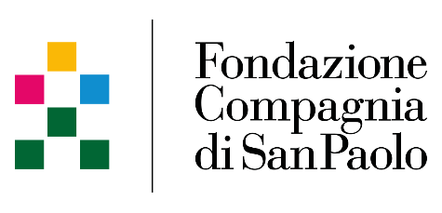

Fondazione Compagnia di San Paolo is a private, independent, non-profit philanthropic foundation with full constitutional autonomy. As such, Fondazione Compagnia di San Paolo manages its assets independently, formulates and implements its own investment policy and allocates the income from its asset management to interventions of collective usefulness through grant-making instruments, whose beneficiaries include public and non-commercial entities with an altruistic mission. By its constitution, “Fondazione Compagnia di San Paolo pursues socially useful purposes, to promote civil, cultural and economic development.”

This general definition applies to the “major areas” of Culture, Research, Public Health and Social Policy. Fondazione Compagnia di San Paolo’s main area of interest is Turin, Piedmont, Liguria and Valle d’Aosta in North West Italy. Nevertheless, as an Italian and European foundation, Fondazione Compagnia di San Paolo also has a secondary but significant range of action in the rest of Italy, in Europe (for projects that include Italian territory) and, for selected initiatives, in the international arena. The Foundation pursues three goals: Culture, People and Planet. Each is articulated in 14 missions, aligning FSCP with the United Nations 2030 SDG Agenda.



The European Research Network on Philanthropy (ERNOP) is an association that was founded in January 2008 by collaborating philanthropy researchers in Europe, in order to advance, coordinate and promote excellence in philanthropic research in Europe.
Currently around 250 members from 25 European countries have joined ERNOP. ERNOP is also open to non-European philanthropy researchers and practitioners. ERNOP members are represented in the most important journals related to philanthropy. The association has good relationships with other (global) research networks such as ISTR and ARNOVA, and it collaborates with other global and European professional philanthropy networks.

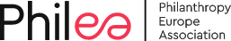

Philea (Philanthropy Europe Association is the voice of European philanthropy)’ purpose is to harness its immense multidimensional potential. Philea nurtures a diverse and inclusive ecosystem of foundations, philanthropic organisations and networks in over 30 countries that work for the common good. It unites over 10,000 public-benefit foundations that seek to improve life for people and communities in Europe and around the world.
Philea aims to inspire, connect and represent the European philanthropy sector and enhance its role as a credible and trustworthy partner, today and tomorrow. It fosters collaboration in order to increase synergies, scale up innovation and use our voice to impact policy that enables positive change.
Philea believes that philanthropy in Europe plays a unique, risk-taking role in sparking innovation and acting as a catalyst for good, and wants to connect citizens and communities with philanthropic organisations and contribute to building more resilient, sustainable and just societies.

Speakers

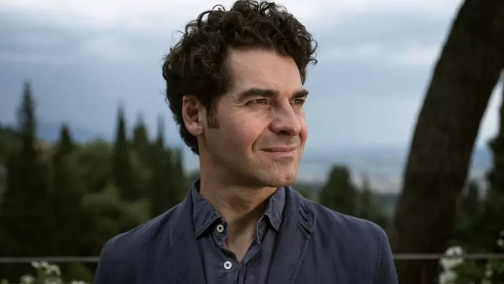
Dr. Alberto Alemanno
Alberto Alemanno is a graduate of Harvard Law School and the College of Europe and holds a PhD in International Law & Economics from Bocconi University. He is the Jean Monnet Professor of European Union Law & Policy at HEC Paris. Alberto’s research has been centred on how the law may be used to improve people’s lives, in particular through the adoption of power-shifting reforms countering social, health, economic, and political disparities of access within society. Alberto is also a permanent visiting professor at the University of Tokyo School of Public Policy and the College of Europe in Bruges, and is a scholar at the O’Neill Institute for National and Global Health Law as well as fellow at The Rutgers Institute for Corporate Social Innovation at Rutgers University.

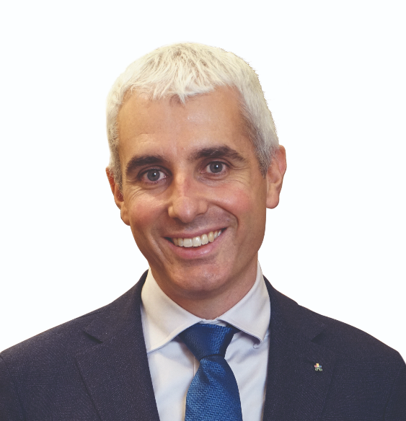
Dr. Alberto Anfossi
Alberto Francesco Anfossi, has a PhD in theoretical physics. After earning a Master's Degree in Economics he worked supporting research groups in attracting and managing competitive funds at EU level. He also worked for the Italian National Agency for Evaluation of Universities and Research Institutes and as Innovation Manager. Alberto has gained many years of experience in the non-profit sector, in particular in the fair-trade movement. He joined Compagnia di San Paolo Foundation in 2013 and was appointed Secretary General on 27 July 2018. He is board member of Collegio Carlo Alberto, REAM sgr, European Alliance for Social Sciences and Humanities, and Philea Nominations and Governance Committee.

Dr. Àngel Font Vidal
Àngel Font Vidal holds a PhD in Economics (Barcelona Ramon Llull University) and a Degree in Chemistry (Barcelona University). He also has a diploma in Business Management from EADA. He began his career as an environmental engineer, and subsequently joined Intermón Oxfam where he held different management positions, first in programmes serving as Latin America Desk Officer and after as a Deputy Director, where he was liaison officer with Oxfam, and strategic planning manager. He funded the Un Sol Món (One World) Foundation financed by Caixa Catalunya, where he runs job placement, social entrepreneurship, and social housing and microfinance projects. In 2010 he joined the “la Caixa” Foundation, in different management positions. Currently he is the Corporate Director of Research and Health. In May 2020 he assumed the Presidency of Philea on behalf of the “la Caixa” Foundation.

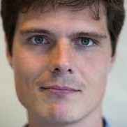
Dr. Barry Hoolwerf

Barry Hoolwerf is Executive Director at the European Research Network on Philanthropy. Barry was trained in Public Administration at VU Amsterdam, has contributed to multiple European studies on philanthropy and was initiator of the first overall study of “Giving in Europe”.

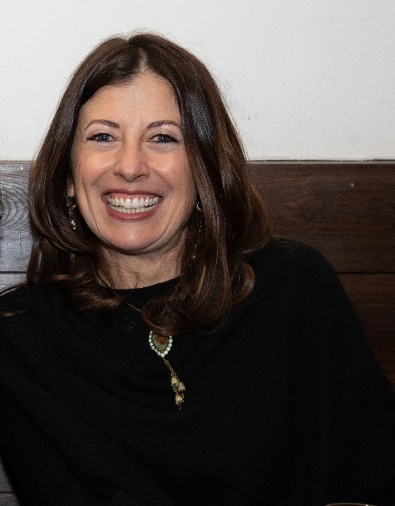
Dr. Carola Carazzone

Carola Carazzone, Italian human rights lawyer with a Master’s in development economics and international Cooperation at University of Pavia, is the Secretary General of Assifero, the Italian association of grantmaking foundations, and Vice-President of Philea-Philanthropy Europe Association.

Dr. Delphine Moralis
Delphine Moralis is the CEO of Philea - Philanthropy Europe Association, which supports foundations, philanthropic organisations and networks working for the common good. She is a former Secretary General of Terre des Hommes International Federation and Missing Children Europe, and has been President of the Board of Directors of Enabel, the Belgian development agency, since 2021.


Dr. Elizabeth McKeon

Liz has worked for multiple donors beginning in 1992 with the John D. and Catherine T. MacArthur Foundation. She joined IKEA Foundation in 2014. Liz is Chair of the Board of Alliance Publishing Trust. She holds an M.P.P. from Harvard’s Kennedy School of Government, and a B.S. in Russian from Georgetown University. Liz is a member of the Council on Foreign Relations and author of Worker Rights in the Global Economy (1998).

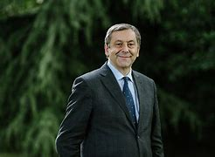
Prof. Francesco Profumo

Francesco Profumo has been Headmaster of Politecnico di Turin, where he currently is Full Professor in Electrical Machines and Drives. He has been president of CNR, Minister of Education, University and Research, and
Presidente del CNR, Ministro dell’Istruzione, Università e Ricerca, Presidente di IREN SpA.
At present, he is president of ACRI, of the Foundation Compagnia di San Paolo and the Bruno Kessler Foundation, in addition to being member of the EIC, European Innovation Council Board.

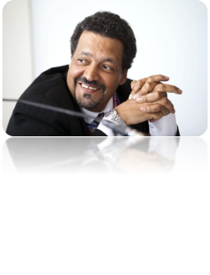
Dr. Gerry Salole

Gerry Salole is an independent consultant offering advice to philanthropic organisations. He describes himself as a participant observer of the institutional philanthropy ecosystem. From 2005 to 2020 Gerry was Chief Executive of the European Foundation Centre (EFC). The EFC (now joined with the former Dafne to form Philea) was an association of over 200 public-benefit foundations and corporate funders active in philanthropy in Europe and elsewhere.
Gerry’s previous posts have included serving as Representative at the Ford Foundation’s Southern Africa office, based in Johannesburg, and Director of the Department of Programme Documentation and Communication of the Bernard van Leer Foundation, based in The Hague. Gerry has also worked for Save the Children Federation (USA) in Ethiopia and Zimbabwe, and Redd Barna (Norwegian Save the Children) and Oxfam UK and UNHCR in Ethiopia.
Gerry studied Social Anthropology and African History at the School of Oriental and African Studies, University of London. He also holds an M.A. (Econ.) and Ph.D. from the University of Manchester.
He is the Founding Chair of TrustAfrica, (Dakar). He is currently Chair of the European Cultural Foundation in Amsterdam, serves on the supervisory board of the Impact Trust, and The Evens Foundation, and he serves on the advisory boards of The Centre for African Philanthropy and Social Investment, The Barilla Centre for Food and Nutrition, and Afrobarometer, and is a strategic advisor to the Africa Europe Foundation.

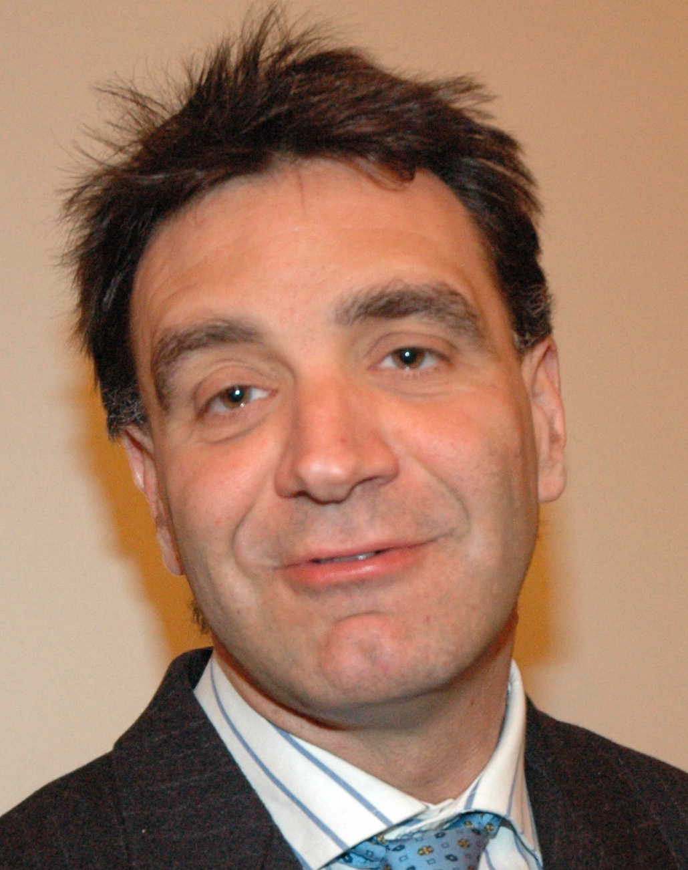
Prof. Gian Paolo Barbetta

Gian Paolo Barbetta is associate professor of Economic Policy at the Università Cattolica del Sacro Cuore di Milano where he is the director of the Research Center on Cooperative and Nonprofit Organizations (CRC). He coordinates Evalab, the unit of the Fondazione Social Venture Giordano Dell’Amore specialising in strategic planning and impact evaluation for philanthropic foundations.

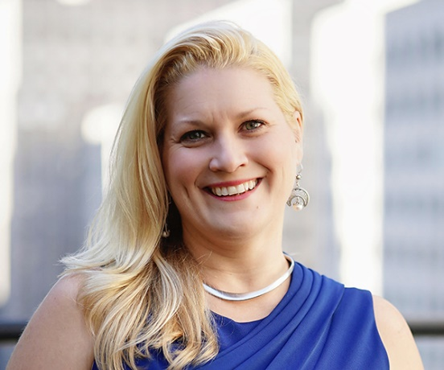
Dr. Olga Tarasov

Olga leads Rockefeller Philanthropy Advisors' research, publications and donor education efforts, as well as its hallmark initiatives, including the Theory of the Foundation and Strategic Time Horizons. Olga holds an M.A. from Georgetown University and a B.A. from The George Washington University.

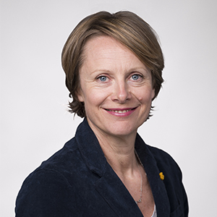
Penelope Lewis

Penelope Lewis is the World Bank’s Special Representative for Southern Europe, based in Rome. She manages relations with the governments of Italy, Spain, Greece and Portugal, as well as with the Vatican, and with United Nations agencies. She is also tasked with strengthening collaboration with the private sector, philanthropy and civil society in those countries. Previously, she established a new Partnership program at the World Bank, which oversaw the institution’s strategic relationships with foundations and the private sector. Before joining the World Bank in 2011, she founded and ran a private consultancy, advising foundations and civil society organizations on effective communications. Previously, at the World Food Program she was based in Rwanda and the DRC, and with UNICEF in the Balkans. Penelope began her career as a journalist with the BBC and holds a Master’s degree from Cambridge University. She is currently a member of the board of Compagnia di San Paolo.
.


Prof. Dr. René Bekkers

Prof. Dr. René Bekkers is full professor of Philanthropy at the Department of Sociology at VU Amsterdam, the Netherlands. His current research takes a multidisciplinary perspective on determinants and consequences of charitable giving and volunteering, and on contributions to non-profit organisations as well as their societal impact.

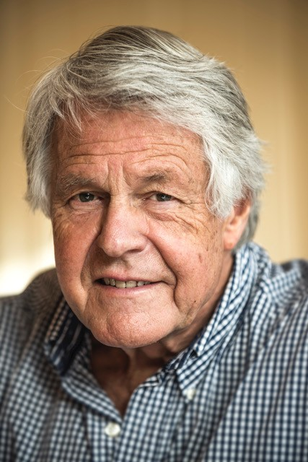
Dr. Rien van Gendt

Rien van Gendt is a member of the Board of Rockefeller Philanthropy Advisors in New York and advisor of the Compagnia di San Paolo in Turin, the Calouste Gulbenkian Foundation in Lisbon and the GSRD Foundation in Amsterdam. He is the trusted advisor of several families and family offices on philanthropy and endowment management in Europe.

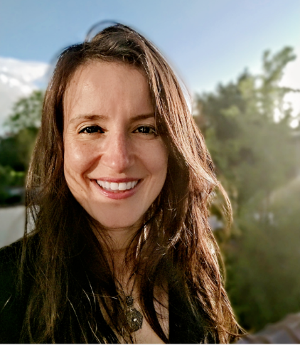
Dr. Sevda Kilicalp

Head of Research and Knowledge Development, Philea -Philanthropy Europe Association. She has worked in and around philanthropy for almost two decades as a researcher, lecturer, practitioner and consultant and is deeply invested in blending practice with the study of philanthropy. She has a PhD in Philanthropic Studies from the Indiana University Lilly Family School of Philanthropy, and an M.A. in Philanthropic Studies and Social Entrepreneurship from the University of Bologna.

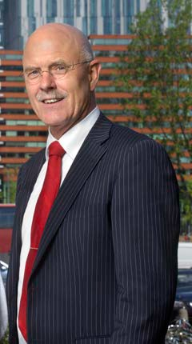
Prof. Theo Schuyt
Theo Schuyt is a Professor in Philanthropic Studies, holding the first chair on philanthropy in Europe, at Vrije Universiteit Amsterdam where he directs the School of Governance. He is a Board Commissioner of the ERNOP “Philanthropy in Europe” project, adviser of Community Foundations in the Netherlands and researcher. Major research fields include Philanthropy, Social Policy, Welfare state and Knowledge Economy.

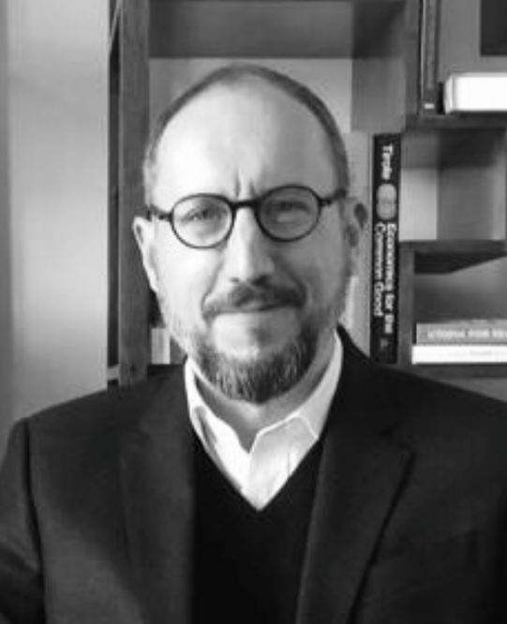
Thomas Venon
Executive Director, Centre for Development Finance Studies, Stockholm. At the CDFS, Thomas conducts applied research and technical advisory work in the field of development finance after accumulating 24 years of experience in asset management and investment banking. He is currently acting as head of product development for the UK Government’s FCDO flagship MOBILIST programme and contributing to the UN’s work towards a repo facility for African sovereign debt.

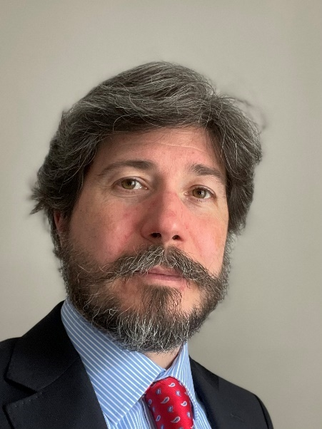
Prof. Tobias Jung
Tobias Jung is Professor of Management at the University of St Andrews, where he heads the School of Management and directs the Centre for the Study of Philanthropy & Public Good. He is a Trustee of Foundation Scotland, Scotland’s community foundation, and the President of the European Research Network on Philanthropy (ERNOP).

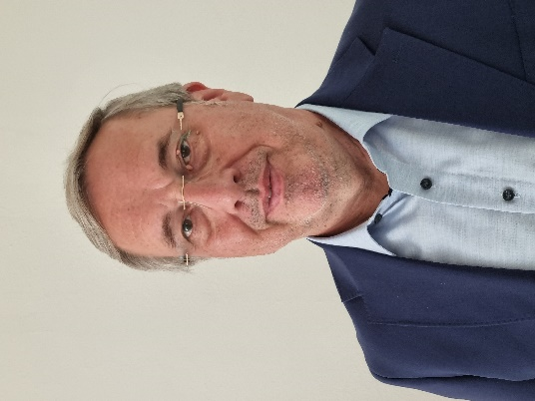
Prof. Volker Then
Volker Then: Chief Executive Officer and Member of the Executive Board, Fondazione AIS – Advancing Impact and Sustainability, Bologna; 2006-2021 Executive Director, Centre for Social Investment, Heidelberg University; 1994-2006 Bertelsmann Foundation, Senior Programme Officer; since 2014 National Advisory Board G7-Social Impact Investment Task Force; since 2021 Scientific Board, OECD Global Action "Social and Solidarity Economy"; member of multiple boards in philanthropy and the Non-Profit-Sector. Key interests: social investment, organisational strategy, and impact measurement.

Venue
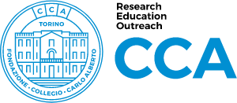
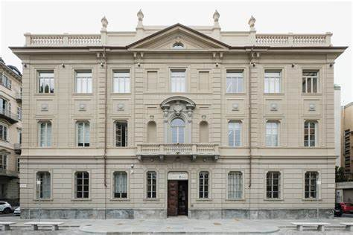

The first record of the building in Piazza Arbarello dates back to 1866 with a listing in the Rabbini Cadastre. At that time, the building was a school overlooking the area that would later become the Piazza, while the back of the building was used as a garden.
In 1928 the City of Turin turned the building into the "Higher Royal Institute of Economic and Commercial Sciences" of Turin, and it later became the Faculty of Economics and Commerce of the University of Turin, which it remained until the 1990s. Today, the Collegio Carlo Alberto is a foundation created in 2004 as a joint initiative of the Compagnia di San Paolo and the University of Turin. Its mission is to foster research and higher education in the social sciences, in accordance with the values and practices of the international academic community. In particular, the Collegio works in close connection with four departments of the University of Turin, which host economists, sociologists, political scientists and jurists.

Piazza Vincenzo Arbarello, 8,
10122,
Torino

Collegio Carlo Alberto

